**SPACE INVADERS GAME**

Space invaders is the classic retro shooting game in which a player has to out-maneuver and shoot down a hoard of incoming aliens before they take over the earth. You can play it at this link <http://www.freeinvaders.org/> (requires flash player). **You have to design and implement a new version of this game with the functionalities that are described below.**

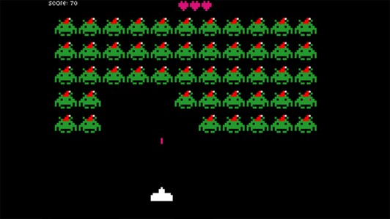

This is a screenshot of the original game to give you a rough idea. *Your* game will look very different with simple shapes instead of images.

GAME FEATURES:

* **Score** must be maintained and displayed throughout the game
* **Player lives** must be maintained and displayed throughout the game
* A **grid of aliens** (at least 5 X 10) must be present that **moves** side to side, and gradually makes its way to the bottom of the screen
* A **player ship** must be displayed at all times that can move UP, DOWN, LEFT, or RIGHT according to the key pressed. It can also shoot a bullet at the aliens.
* You must include a **pause** feature (for eg: by pressing ESC or pressing P) which will pause the game until the key is pressed again.
* You must include a **save state** feature such that you can close the game and resume it at a later time. This will involve saving data into a txt file and then later retrieving it.
* You must include a **high-score** feature. Your game must maintain a record of the 5 highest scores. These records must not be lost when the game is closed.

**Additional Notes:**

* The player must be able to move in all 4 directions (UP, DOWN, LEFT, RIGHT). Not just side to side.
* The player’s life must decrease if it collides with an alien. If the lives drop to zero, the game is over.
* Alternatively, if even one alien reaches the bottom of the screen the game is over.
* The aliens must be destroyed if it collides with the bullet. The bullet must also disappear if it collides or reaches the top of the screen.
* If all the aliens are killed, the game is over and the player has won.
* You can choose to have only one bullet on the screen at a given time.
* The objects on the screen (player, aliens, bullet) can be simple shapes (squares, rectangles, triangles), but try to differentiate between these objects by using different colors or shapes.
* You can have your own choice of key bindings for controlling the game (eg: using WASD or using arrow keys)

Any additional features that you implement to improve the gameplay or the look of the game will be considered positively during your project evaluation. So strive to make your game unique and enjoyable.

**Submission Instructions:**

* You must use the graphics library you have been provided for rendering graphics and handling events.
* You must submit a working, executable along with a source code. Also include a README file that details how to launch the game.
* You must follow good programming practices. Your code should be properly indented, with meaningful variable and function names, and with comments where necessary.